FEAR – Sound Channels

Introduction

This document is intended to be a quick reference guide for deciding which sound channel to use when placing SoundFX and Music tracks in your level.

MixChannel

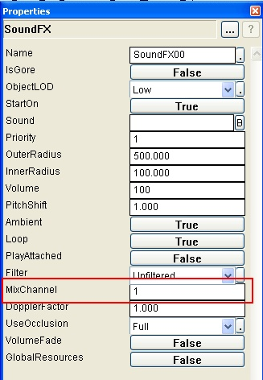

When talking about which channels to mix sounds into, I am referring to the “MixChannel” property in the SoundFX object. By default it sets itself to “1” which will cause whatever sound effect you’ve chosen for this particular object to be affected by SlowMo. However if you set the SoundFX object’s “MixChannel” to either 2, 12, or 13, the sound you selected will not be affected by SlowMo.

For example, you’ll usually want to set your music tracks to channel 2 or to channel 12. Sometimes the track might not play on one of them so you might have to experiment and see what gives you the best results. You’ll find that 99% of the time, you’ll want to have your music tracks be unaffected by SlowMo, mostly because it sounds really ridiculous when the tempo is cut in half.

Default Mixing Channels

1 – Default
2 – Music (not affected by Slowmo)
3 – Weapons_Player
4 – Weapons_nonPlayer
5 – Footsteps_Player
6 – Footsteps_nonPlayer
7 – Ambient
8 – Physics
9 – Weapon impacts
10 – Speech
11 – Objects
12 – UI (not affected by Slowmo)
13 – No-pitch ambient (not affected by Slowmo)

